Google:

1. In the top right hand corner of your gmail click on your name icon and hit signout.

2. Go to [https://nationalfloodservices.okta.com](https://nationalfloodservices.okta.com/), login and click on the icon for Google Workspace Mail (If you are connected to the NFS network it will just auto sign in using your computer credentials).

3. This should launch Google Mail and you are authenticated as before but with the new Okta instance.  You are done for Google products.

Zoom:

1. Open up Zoom and in the top right hand corner click the icon that represents your name like below.

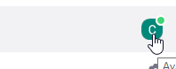

2. Click Sign out

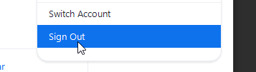

3.. Click sign in with SSO

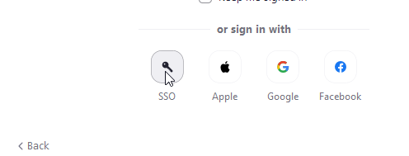

4. Type nationalfloodservices in the box as seen below.

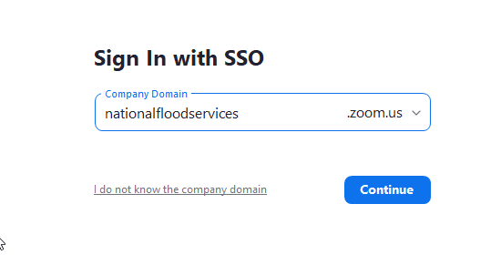

5. If you already signed in above for google, you will just auto sign into Zoom.

6. Zoom should be logged in and your steps are now complete.