Resource Type: Email Outreach Template
Audience: Florida Homeowners
Directions: Copy and paste the template below into your preferred email platform. HTML email formatting is preferred.

Subject: Citizens’ Flood Insurance Requirement – Your Property Requires Flood Coverage
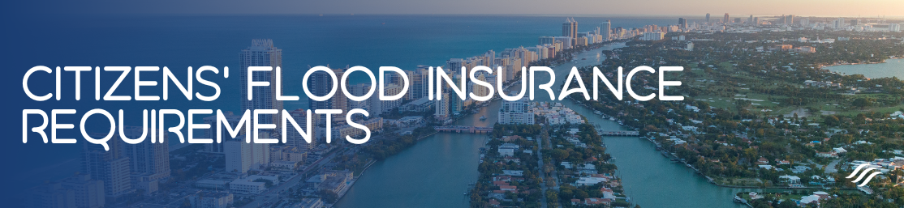
Citizens’ Flood Insurance Requirements
Dear Insured Name Here:
As a valued client of Agency Name Here, I am writing to advise you of a new Florida Law (Fla. Stat. §627.351(6)(aa)) that requires flood insurance. All property owners renewing personal residential policies with Citizens, that include wind coverage and where the insured property is located in a special flood hazard area, are now required to carry flood insurance.
Per the new requirement, an active flood insurance policy needs to be in place in order to allow the renewal of your Citizens’ homeowners policy. For existing Citizens policyholders meeting the guidelines referenced above, the new requirement will apply to renewal policies with effective dates on or after July 1, 2023.
To reiterate, if a flood insurance policy is not purchased, your Citizens’ personal residential policy cannot be renewed.
We have attached your quote for flood insurance, please review and submit the premium at your earliest convenience to avoid nonrenewal of your homeowners policy. If you would like to discuss your quote or have any questions, please contact us at Agency Contact Info Here.
Sincerely,
Agent name here.
Agent Phone Number.
Agent Email Address.
Office Address here.

