**Job Aid**

| **Title:** | **Using Documents link in Trident** | | |
| --- | --- | --- | --- |
| **Document #:** | **WFM Assigns** | **Original:** | 10/5/22 |
| **Rev Level:** | 2 | **Rev Date:** | 10/4/2022 |
| **Author:** | Foy | **Owner:** | Jeremy Jones |

The *Documents* link located in Trident provides the ability for agents and internal users to view and download documents that have been uploaded to Trident as well as any documents that have been generated by Trident. In addition, agents will also be able to see Legacy documents. The ability to view Legacy documents is not currently available for internal users. The *Documents* link is accessible from both the Policy Summary page as well as each individual Policy Builder.

Follow the procedures below to access the policy documents. These procedures assume the user has already accessed the policy in Trident and is on the Policy Summary or Policy Builder page.

1). Click on the *Documents* link.

**From Policy Summary:**

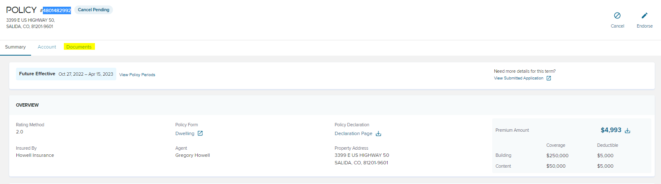

**From Policy Builder:**

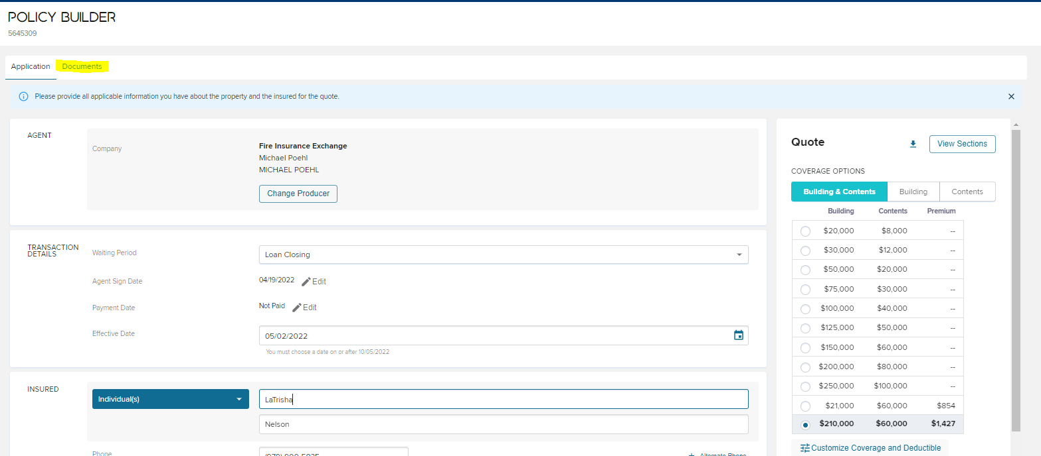

2). The Documents page will be opened displaying all documents received in Trident as well as any documents generated by Trident (i.e. quote). Documents will be displayed in chronological order from most recent at the top, to the oldest at the bottom of the list. The agent will also be able to see any Legacy documents.   
  
Review the list of documents and select the down arrow next to the document to be viewed.

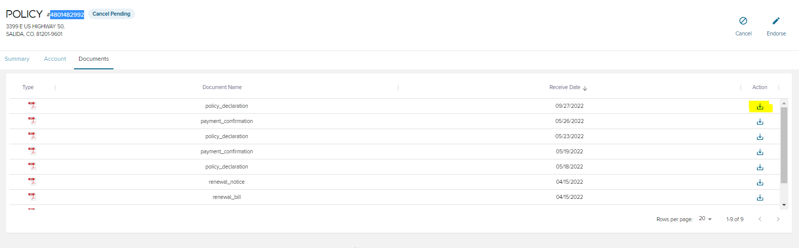

**Note**: The user can change the sort criteria for how the documents will display by clicking on the *Document column* header to order by document type or the *Receipt Date* column header to order from oldest to most recent.

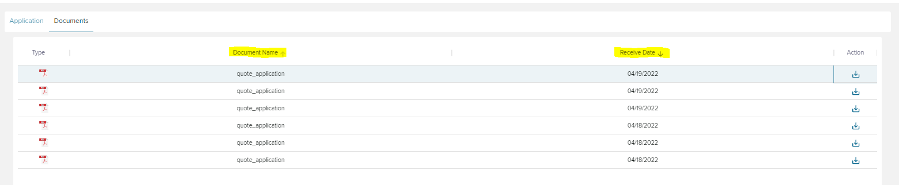

3). Click on the PDF image that will be displayed at the bottom of the list to open the document selected .

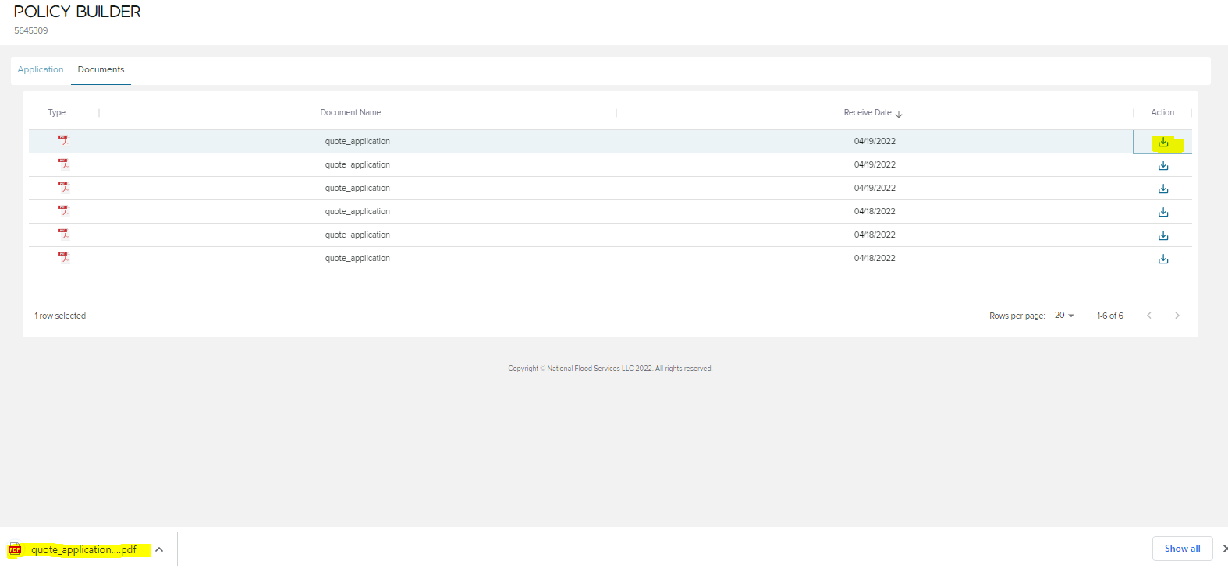

Note: The system captures a static version of the policy, every time policy data is altered and saved to the policy. In the above example, the quote is displayed 6 times. The original version listed at the bottom is the original quote (if opened coverages reflect 21K building coverage) and the top quote listed is the most recent version (if opened coverages reflect $210 building coverage.)

4). The document will be displayed. The user can print the document by clicking on the printer icon or download the document by clicking on the down arrow.

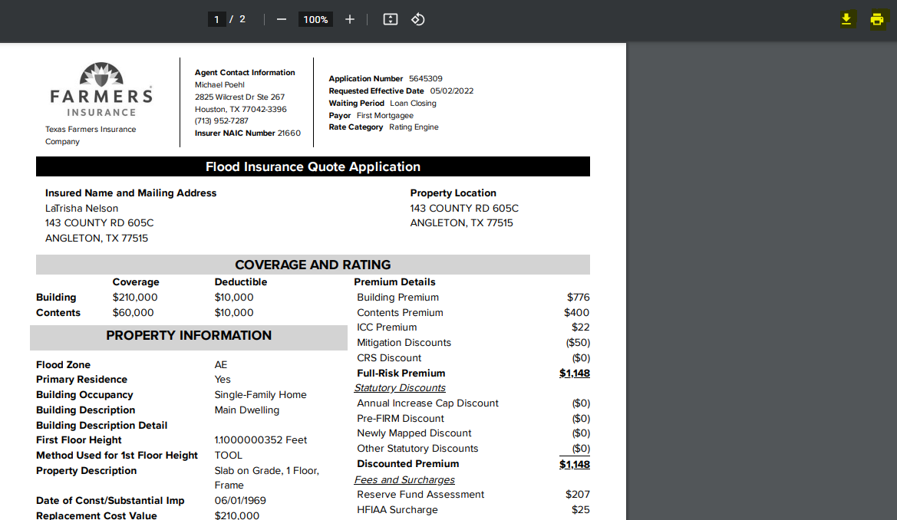

# **Change History**

| Rev | Rev Date | Author | Change Made |
| --- | --- | --- | --- |
| 1 |  |  |  |
| 2 |  |  |  |
| 3 |  |  |  |
|  |  |  |  |