**Job Aid**

| **Title:** | **Creating and confirming First Notice of Loss (FNOL) in Trident** | | |
| --- | --- | --- | --- |
| **Document #:** | **WFM Assigns** | **Original:** | 9/30/22 |
| **Rev Level:** | 2 | **Rev Date:** | 10/4/2022 |
| **Author:** | Foy | **Owner:** | Who Approves? |

The FNOL can be quickly and easily reported using the Trident system by both the agent and the Underwriter/CSR. Although it is the most efficient way to report the loss, the agent and insured can also access the insured.myflood.com site to report a claim. . In addition, if the user receives an error message at the time of submission, the FNOL Tracking Form or the Risk Rate 2.0 Claims Spreadsheet can also be used to manually report the loss. Trident can also be used to determine if a loss has been previously submitted and to identify the assigned adjuster or claims examiner assigned to the claim (previously obtained through Claims Detail Report.)

Follow the procedures below to report the FNOL using the Trident system.

1). Search for the policy that has had the loss   
.

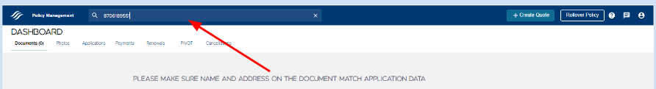

2). Select the policy from the search results.

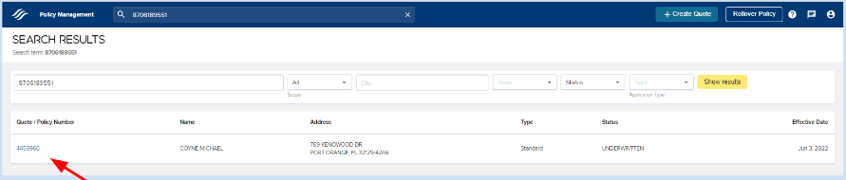

3). The Policy Summary page will be displayed. Confirm the insured name and property address with the caller. In addition, confirm the policy is currently in force and identify the rating methodology.

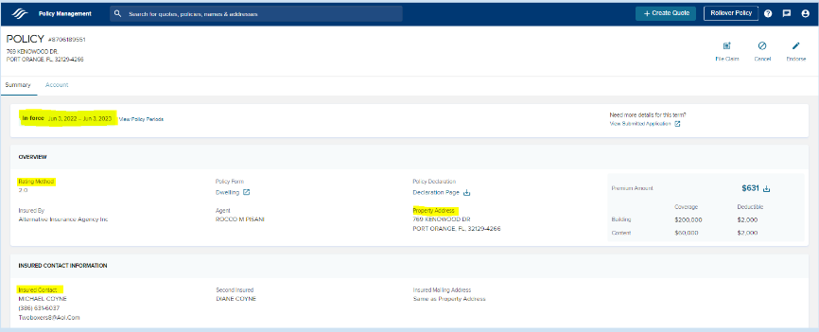

4). Before proceeding with the claim, click on the *Claims* link located on the Policy Summary page to confirm that the claim has not already been reported.   
  
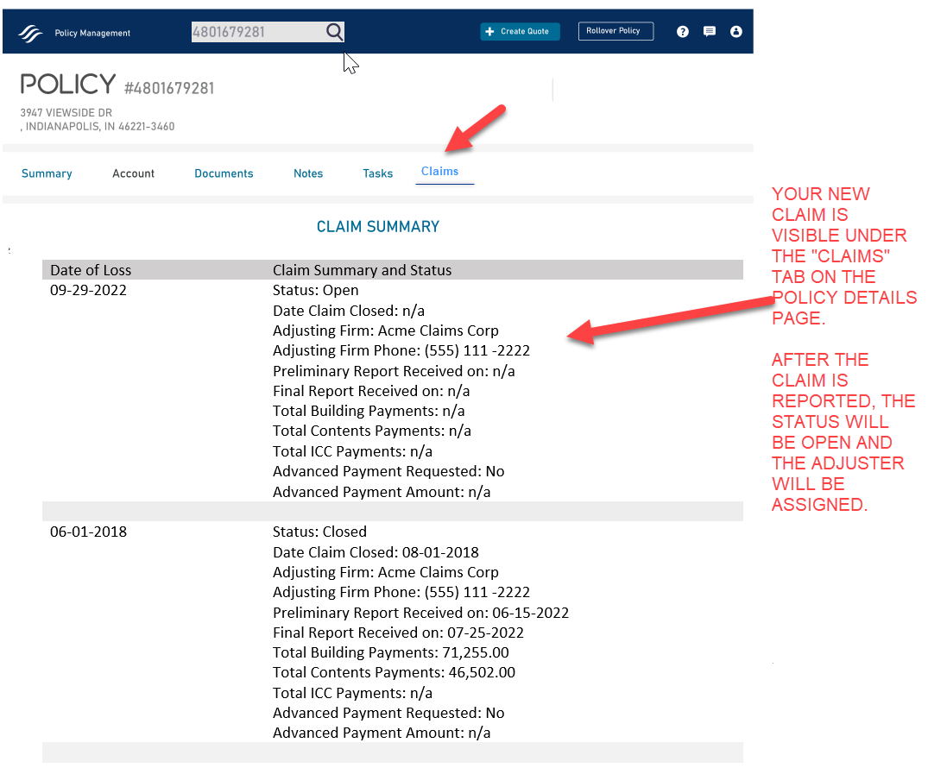

**Note:**

Reported claims will be listed in chronological order from most recent to oldest.

If the date of loss is already listed, then the claim has already been reported and you can provide the caller with the adjuster name and phone number. Do NOT report the loss again.

If the date of loss is not listed, then user can proceed to reporting the claim.

5). Click the *Summary* link to return to the Policy Summary page and click on File Claim icon to report the loss.   
  
Note: Be sure to adjust the policy period that the loss occurred in if needed by clicking on the View Policy Periods link before clicking on File Claim.

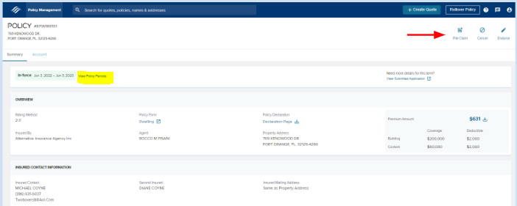

6). The First Notice of Loss page will open in a new tab.   
  
Note: This screen looks identical to the FNOL screen in insured.myflood.com.

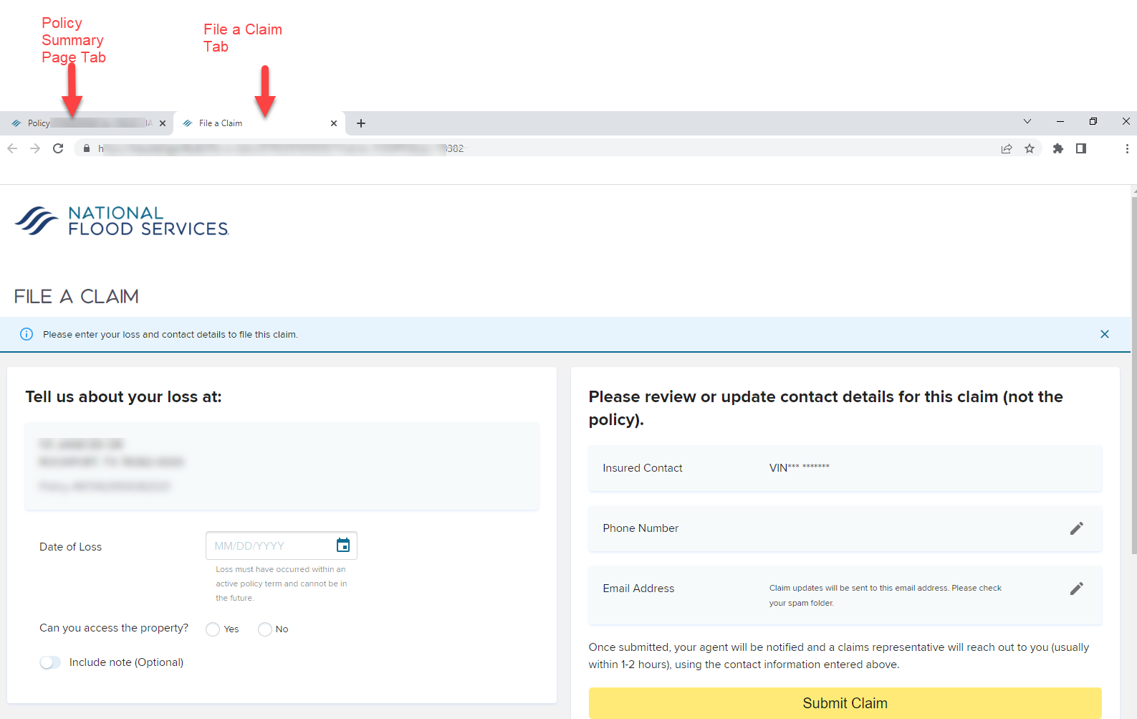

7). Complete all of the entry fields on the screen and click “Submit Claim”. Be sure to confirm the phone number and email they would like to use for the claim and update accordingly.

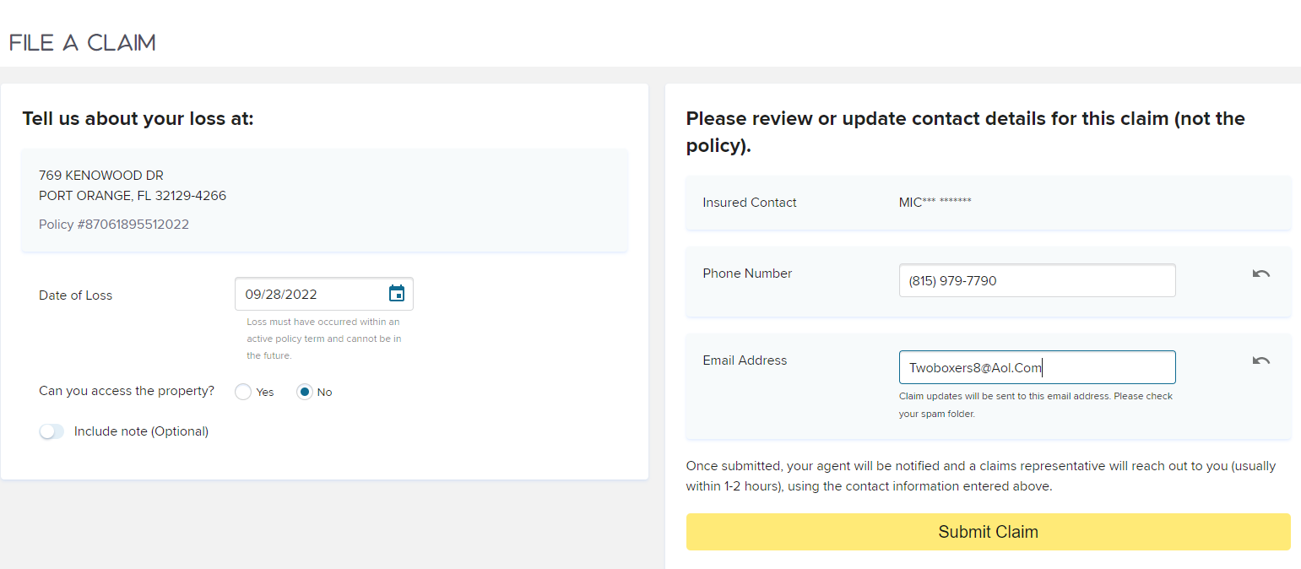

* **Date of Loss** = the date the water reached the insured structure.
* **Can you access the property** = Indicate if the insured is able to access the property. If the caller is not sure, select No.
* **Include Note** = Use this area to provide additional contact information, corrections that need to be made to policy regarding lenders, etc or to provide any other pertinent information provided by caller regarding the loss. Note: This does NOT update the policy information, but the info is forwarded to claims.
* **Phone Number =** The system will auto-display the last 4 digits for the policy number on file. Confirm that this is the BEST number for the insured to be reached at regarding the claim. Update as needed.
* **Email Address =** The system will auto-display the email address on file. Confirm that this is the BEST email to be used regarding the claim. Update as needed. This is the email address where the claims confirmation will be sent.

8). The “Your Flood Claim has been successfully sent” message will be displayed after pressing the “Submit Button.” An email will be systematically generated to the insured email address provided on the FNOL submission.

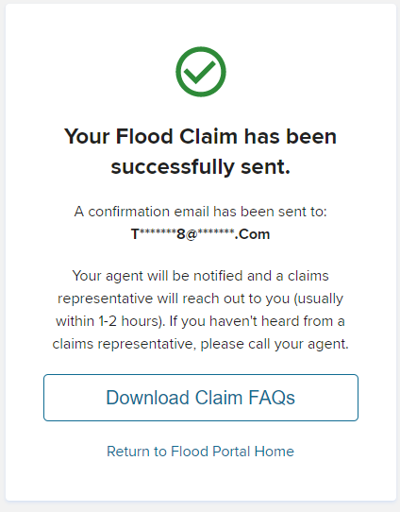

9). To return back to the policy, close the tab for “file a claim” or user can simply click on the Policy Summary tab at top of the screen

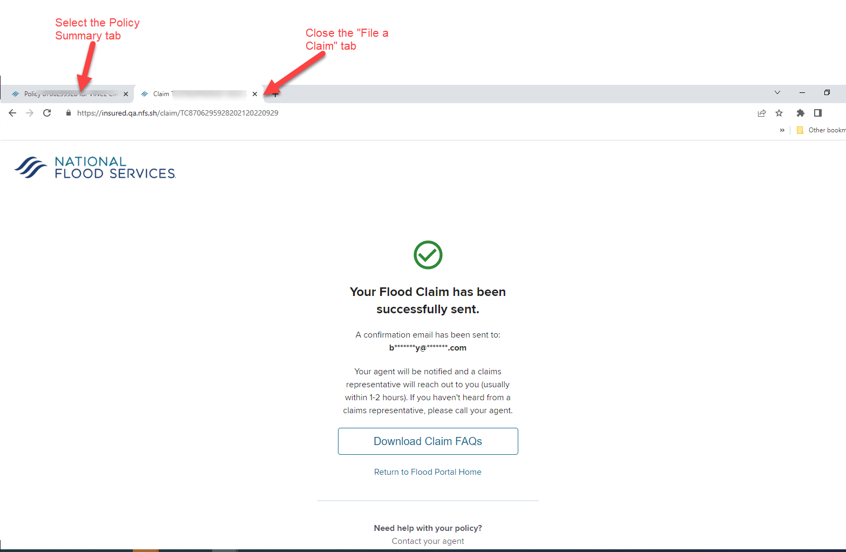

10). Below is a copy of the email that is sent to the insured at the email provided in the FNOL   
 submission. A copy of the email cannot be regenerated.

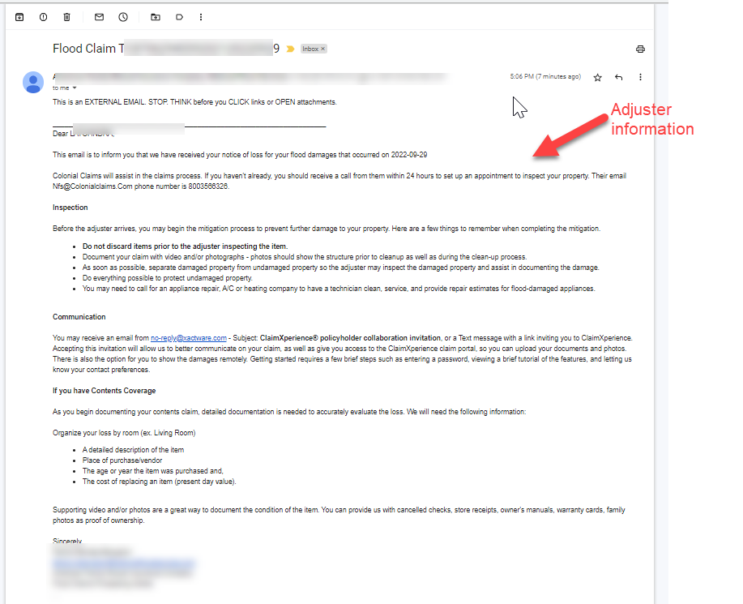

11). If user receives an error message upon submission that the FNOL failed OR the CSR identified earlier that the loss occurred during in active policy term, the CSR should manually report the loss using one of the two links below depending on whether the policy term impacted was rating with Legacy rating or 2.0 rating.

**Link for 2.0 Rating:**

<https://docs.google.com/spreadsheets/d/1DyQ68pdQQtkSZPIB0KCjzm82i9Ev05ShJHwcctlZ2Mo/edit#gid=0>

**Link for 1.0 (Legacy )Rating**:

<https://docs.google.com/forms/d/e/1FAIpQLScVfslbF-YR16oiBbbUiFi1pi1zfsbMcod_9u380pNGH3TfLA/viewform>.

.

# **Change History**

| Rev | Rev Date | Author | Change Made |
| --- | --- | --- | --- |
| 1 |  |  |  |
| 2 |  |  |  |
| 3 |  |  |  |
|  |  |  |  |