Resource Type: Email Outreach Template
Audience: Miami-Dade Homeowners
Directions: Copy and paste the template below into your preferred email platform. HTML email formatting is preferred.

Subject: Miami-Dade Exclusive Flood Insurance Savings for You!
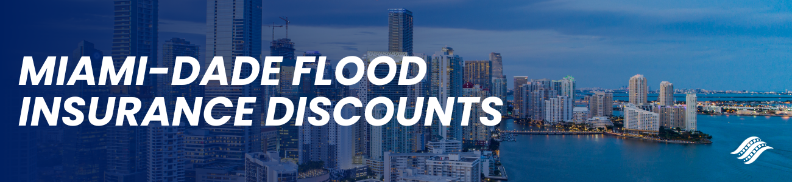
Miami-Dade Flood Insurance Discounts
Dear Insured Name Here:
As a valued client of Agency Name Here, we are excited to share significant news regarding your flood insurance coverage. Miami-Dade County has achieved a remarkable Class 3 rating in the National Flood Insurance Program Community Rating System (CRS), resulting in an estimated $12 million in annual savings.
Key Benefits for You:
- Save Money: You could receive a 35% discount on your flood insurance premiums, contributing to significant annual savings.
- Enhanced Protection: Miami-Dade's commitment to flood mitigation means added protection for your home and peace of mind.
- Invest in Your Future: Join the community in building resilience against climate threats, ensuring a safer, more secure future for your home.
Starting April 1, 2024, most homeowners qualify for this exclusive discount on National Flood Insurance Program (NFIP) policies issued or renewed. We have attached your quote for flood insurance, please review and submit the premium at your earliest convenience. If you would like to discuss your quote or have any questions, please contact us at Agency Contact Info Here.
Thank you for choosing Agency Name Here for your insurance needs. We look forward to continuing to serve you and ensuring your peace of mind.
Sincerely,
Agent name here.
Agent Phone Number.
Agent Email Address.
Office Address here.

