Resource Type: Email Outreach Template
Audience: Miami-Dade Businesses
Directions: Copy and paste the template below into your preferred email platform. HTML email formatting is preferred.

Subject: Unlock 35% Savings on Flood Insurance with Miami-Dade CRS Class 3 Rating!
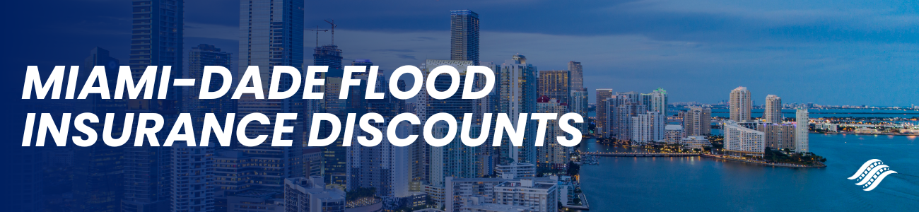
Miami-Dade Flood Insurance Discounts
Dear Insured Name Here:
As a valued client of Agency Name Here, we are delighted to inform you of a significant development that directly impacts your business. Miami-Dade County has achieved a remarkable Class 3 rating in the National Flood Insurance Program Community Rating System (CRS), resulting in an estimated $12 million in annual savings.
Key Business Advantages:
- Financial Savings: Your business could now benefit from a substantial 35% discount on flood insurance premiums, contributing to significant annual cost savings.
- Heightened Protection: Miami-Dade's steadfast commitment to flood mitigation ensures added protection for your business property, providing you with peace of mind.
- Community Resilience: Join fellow businesses in building resilience against climate threats, contributing to a safer and more secure future for your business operations.
Starting April 1, 2024, businesses in Community Name qualify for this exclusive discount on National Flood Insurance Program (NFIP) policies issued or renewed. To assist you in taking advantage of this opportunity, we have attached your personalized quote for flood insurance. Kindly review the details and submit the premium at your earliest convenience. If you would like to discuss your quote or have any questions, please contact us at Agency Contact Info Here.
Thank you for choosing Agency Name Here for your insurance needs. We look forward to continuing to serve you and ensuring your peace of mind.
Sincerely,
Agent name here.
Agent Phone Number.
Agent Email Address.
Office Address here.

