Resource Type: Email Outreach Template
Audience: Maine Homeowners
Directions: Copy and paste the template below into your preferred email platform. HTML email formatting is preferred.

Subject: It’s Not Too Late to Enroll for Flood Coverage
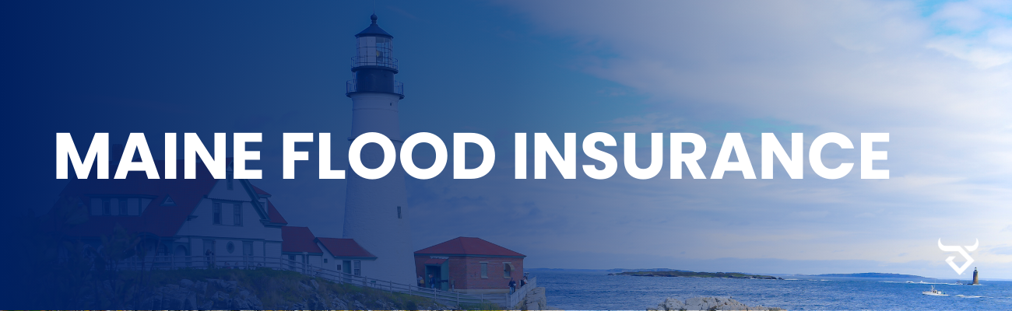
Dear Insured Name Here:
Maine's picturesque landscapes are a source of pride, but they also bring unique challenges, particularly when it comes to flooding. No matter where you live, it's crucial to understand the flood risks that may affect your home and family.
Flooding can happen at any time, anywhere. I am reaching out to remind you that I am available to discuss any coverage questions, provide information about your property’s flood risk and protection options available.
Remember:
Just one inch of water in an average-sized home can cause more than $25,000 in damage
Flooding can happen anywhere, not just in “high-risk” flood areas
Federal disaster assistance is not available for most flood events and is typically given in the form of an interest-bearing loan
Your homeowners insurance will not protect you from flood damage
If you would like to discuss a flood insurance quote or have any questions, please contact us at Agency Contact Info Here.
Sincerely,
Agent name here.
Agent Phone Number.
Agent Email Address.
Office Address here.

