Resource Type: Email Outreach Template
Audience: Commercial Property & Content Owners
Directions: Copy and paste the template below into your preferred email platform. HTML email formatting is preferred.

Subject: Protect the Life you’ve Built from Post-Wildfire Flood Risks
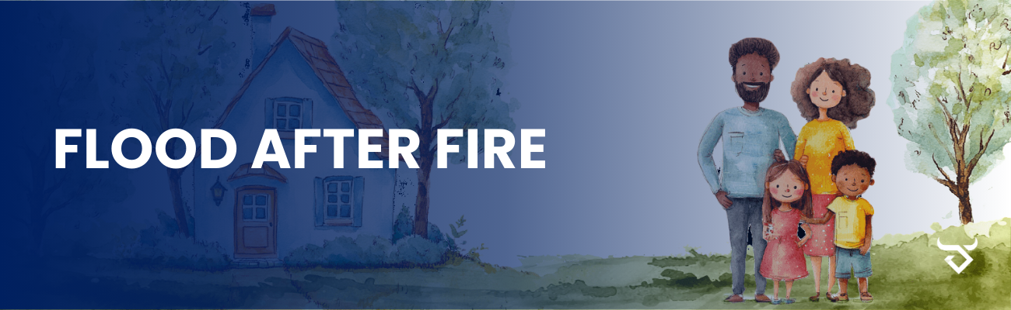
Dear Insured Name Here:
Did you know that wildfires can increase the risk of flooding by up to 4 times? When vegetation is burned and the ground is scorched, it can no longer absorb water effectively, making flash floods and mudslides far more likely. This heightened risk can persist for up to 5 years after a wildfire.
Even properties outside high-risk flood zones are vulnerable—25% of flood insurance claims come from moderate- to low-risk areas. Without flood insurance, the financial burden of flood damage can be overwhelming. The average flood claim between 2016 and 2022 was over $66,000—an expense no homeowner should face alone.
If you would like to discuss a flood insurance quote or have any questions, please contact us at Agency Contact Info Here. Together, we can ensure the life you’ve built is protected from post-wildfire flood risks.
Sincerely,
Agent name here.
Agent Phone Number.
Agent Email Address.
Office Address here.

