Resource Type: Email Outreach Template
Audience: Commercial Property & Content Owners
Directions: Copy and paste the template below into your preferred email platform. HTML email formatting is preferred.

Subject: Protect Your Business from Post-Wildfire Flood Risks
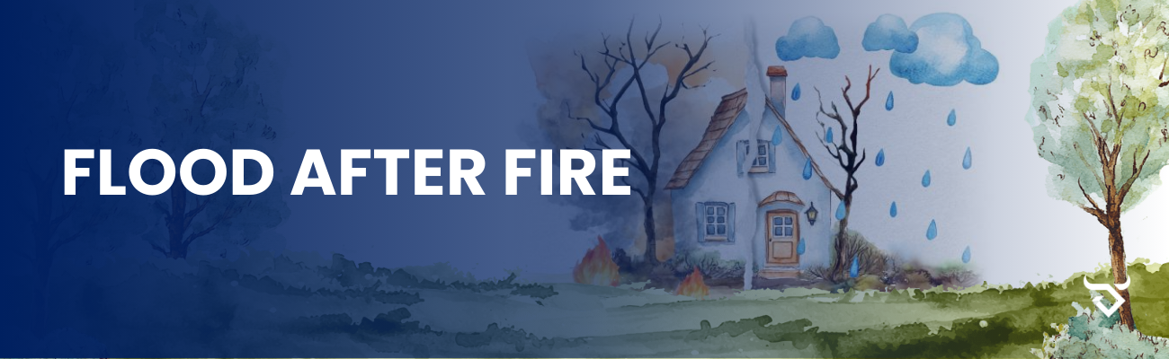
Dear Insured Name Here:
As a business owner, protecting your property from unexpected events is essential, especially following a wildfire. It’s important to understand that areas affected by wildfire face a significantly higher risk of flooding.
Wildfires can destroy vegetation and alter the landscape, leaving the land vulnerable to flash floods, mudslides, and erosion. In fact:
Properties in wildfire-affected areas are 4 times more likely to experience flooding.
Flood risk remains significantly higher until vegetation is restored, about 5 years or more after a wildfire.
The average flood insurance claim between 2016 and 2022 was over $66,000
Flood insurance is the best way to protect your property and operations from the financial impact of flooding. I encourage you to review your current coverage or explore flood insurance options tailored to your needs.
If you would like to discuss a flood insurance quote or have any questions, please contact us at Agency Contact Info Here. Together, we can ensure your business is protected from post-wildfire flood risks.
Sincerely,
Agent name here.
Agent Phone Number.
Agent Email Address.
Office Address here.

